**Mingei (民芸)**

‘Mingei’ denotes a concept that encompasses objects, aesthetics and philosophy. It was coined in Japan in the mid-1920s by three men: religious philosopher and aesthete Yanagi Muneyoshi (Sōetsu 柳宗悦, 1889-1961), and potters Hamada Shōji (浜田庄司, 1894-1978) and Kawai Kanjirō (河井寛次郎, 1890-1966). Recognising the beauty in humble folk craft objects sold at markets, they eventually conceived the term *minshū-teki kōgei* (craft with characteristics of people) and shortened it to Mingei. Typical Mingei objects were handcrafted wares from pre-modern eras produced in large quantities for ordinary people’s everyday use. Yanagi claimed that their beauty – the simplicity, robustness and honesty to material – was of a kind that was “born, not made” and one could recognise it through “direct perception”, that is, “seeing before knowing”. [Image] The Mingei theory was informed by wide-ranging Japanese and non-Japanese ideas including those of John Ruskin, William Morris, William Blake, Walt Whitman, Émile Mâle and many others as well as the British potter Bernard Leach (1887-1979). This appreciation developed into a movement through research and propagation in the magazine *Kōgei* (*Craft*: 1931-51).

The Japan Folk Crafts Association (Nippon Mingei Kyōkai), founded in 1934, established a nationwide network for Mingei and some regional leaders began reviving declining local crafts through support, education and promotion as New Mingei. In 1936 Yanagi built a museum in Tokyo to house his collection and to demonstrate the beauty of Mingei.

Initially collected for beauty and later defined in terms of origins, Mingei was imbued with contradictions: not all objects claiming to be ‘Mingei’ were made for common people; the movement promoted handicrafts, which were increasingly costly in the industrialised world; and few ‘New Mingei’ works achieved the aesthetic standard of Yanagi’s collection. Also, as Mingei emerged at the time when crafts were taken up in Japan as a means of creative expression, Yanagi’s claim that no work created consciously by an artist could surpass the beauty of Mingei alienated some artists and critics. The distinction between Mingei and consciously created craftworks was a major issue for artists inspired by Yanagi’s ideas. Yanagi’s solution to this problem was his ‘Buddhist aesthetic’, launched in 1948, in which he discussed two approaches to beauty - ‘self-power’ and ‘other-power’ - and promised that in Buddha’s realm the distinction between beauty and ugliness ceases to exist.

Bernard Leach introduced the idea of Mingei in English in *A Potter’s Book* (1940). In the Western world where the memory of Arts and Crafts ethics lingered, Mingei provided a new and highly developed philosophy of creative life and aesthetic standard for post-WWII studio craftspeople, spreading in tandem with Zen teachings of spiritual freedom.

**Further reading**

----*Mingei: two centuries of Japanese folk art* (1995) bilingual exhibition catalogue

Brandt, Kim (2007) *Kingdom of beauty: Mingei and the politics of folk art in Imperial Japan*, Durham, NC: Duke University Press.

Kikuchi, Yuko (2004) *Japanese modernization and* Mingei *theory: cultural nationalism and Oriental Orientalism*, London & New York: RoutredgeCurzon.

Nakami, Mari (2011) *In pursuit of composite beauty: Yanagi Sōetsu, his aesthetics and aspiration for peace*, Melbourne: Trans Pacific Press & Tokyo: University of Tokyo Press.

Yanagi, Sōetsu (adapted by Leach, Bernard) (1972) *The Unknown Craftsman: a Japanese insight into beauty*, New York: Kodansha International.

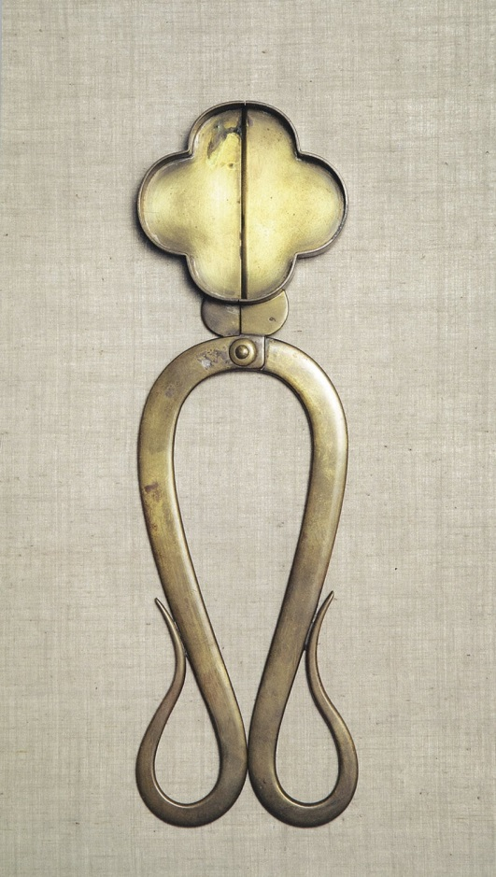

Wick cutter

Kyoto, 20th century

brass; 30.5 x 9.4cm

The Japan Folk Crafts Museum

<http://www.mingeikan.or.jp/english/>